ATRIJ ROY

ROLL NO:002311001086

JU IT A3

ASSIGNMENT 4

QUESTION:-

Consider a BANK database. Each bank can have multiple branches, and each branch can have multiple accounts and loans. Assumptions also can be made. Design an ER diagram and database schema for the system. Specify the primary key, foreign key and other constraints for all required tables. Draw the ER diagram in MS Word.

## ER DIAGRAM.

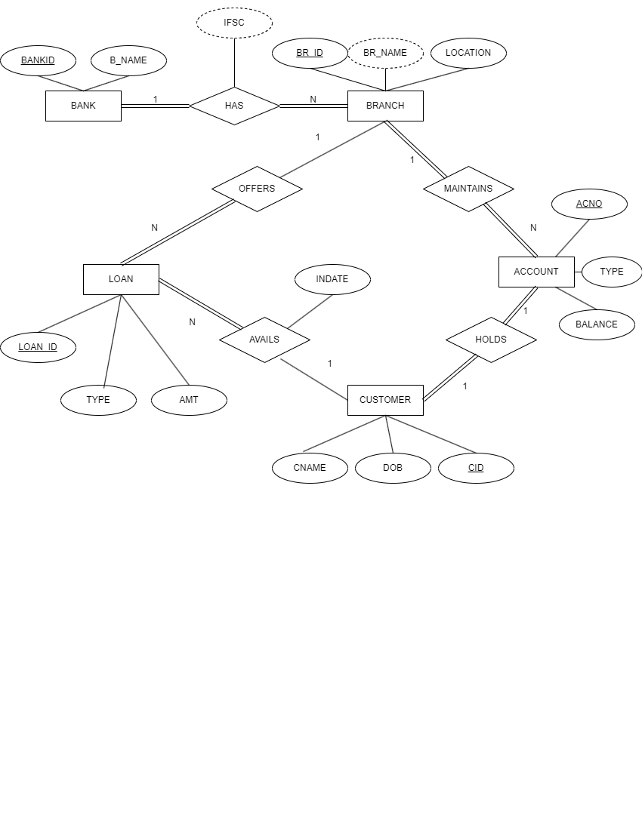

## RELATION SCHEMA

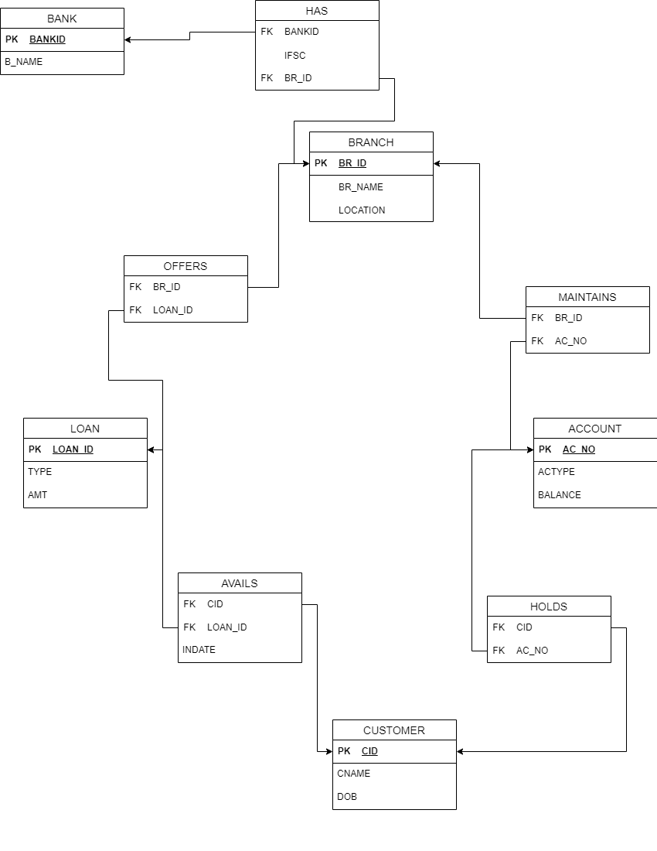

### Insert at least five tuples in each table.

CREATE TABLE BANK(

BANKID NUMBER(2) PRIMARY KEY,

B_NAME VARCHAR2(15) NOT NULL

);

CREATE TABLE BRANCH(

BR_ID NUMBER(3) PRIMARY KEY,

LOCATION VARCHAR2(15) NOT NULL,

BR_NAME VARCHAR(15)

);

CREATE TABLE HAS(

BANKID NUMBER(2),

BR_ID NUMBER(3),

PRIMARY KEY(BANKID,BR_ID),

FOREIGN KEY(BANKID) REFERENCES BANK(BANKID) ON DELETE CASCADE,

FOREIGN KEY(BR_ID) REFERENCES BRANCH(BR_ID) ON DELETE CASCADE,

IFSC VARCHAR2(20));

CREATE TABLE ACCOUNT(

AC_NO NUMBER(15) PRIMARY KEY,

ACTYPE VARCHAR2(15) NOT NULL,

BALANCE NUMBER(15) NOT NULL

);

CREATE TABLE MAINTAINS(

BR_ID NUMBER(3),

AC_NO NUMBER(15),

PRIMARY KEY(BR_ID,AC_NO),

FOREIGN KEY(BR_ID) REFERENCES BRANCH(BR_ID)ON DELETE CASCADE,

FOREIGN KEY (AC_NO) REFERENCES ACCOUNT(AC_NO)ON DELETE CASCADE,

);

CREATE TABLE CUSTOMER(

CID NUMBER(2) PRIMARY KEY,

CNAME VARCHAR2(15) NOT NULL,

DOB DATE NOT NULL

);

CREATE TABLE HOLDS(

AC_NO NUMBER(15),

CID NUMBER(2),

PRIMARY KEY(CID,AC_NO),

FOREIGN KEY(AC_NO) REFERENCES ACCOUNT(AC_NO) ON DELETE CASCADE,

FOREIGN KEY(CID) REFERENCES CUSTOMER(CID) ON DELETE CASCADE,

);

CREATE TABLE LOAN(

LOAN_ID NUMBER(2) PRIMARY KEY,

LTYPE VARCHAR2(15) NOT NULL,

AMT NUMBER(10) NOT NULL

);

CREATE TABLE AVAILS(

CID NUMBER(2),

LOAN_ID NUMBER(2),

INDATE DATE NOT NULL,

PRIMARY KEY(CID,LOAN_ID),

FOREIGN KEY(CID) REFERENCES CUSTOMER(CID),

FOREIGN KEY (LOAN_ID) REFERENCES LOAN(LOAN_ID)

);

CREATE TABLE OFFERS(

BR_ID NUMBER(3),

LOAN_ID NUMBER(2),

PRIMARY KEY(BR_ID,LOAN_ID),

FOREIGN KEY (LOAN_ID) REFERENCES LOAN(LOAN_ID),

FOREIGN KEY (BR_ID) REFERENCES BRANCH(BR_ID)

);

INSERT INTO BANK VALUES(1,'SBI');

INSERT INTO BANK VALUES(2,'PNB');

INSERT INTO BANK VALUES(3,'CANARA BANK');

INSERT INTO BANK VALUES(4,'AXIS BANK');

INSERT INTO BANK VALUES(5,'ICICI BANK');

INSERT INTO BRANCH VALUES(1,'SALTLAKE',NULL);

INSERT INTO BRANCH VALUES(2,'SEALDAH',NULL);

INSERT INTO BRANCH VALUES(3,'SEALDAH',NULL);

INSERT INTO BRANCH VALUES(4,'PARKSTREET',NULL);

INSERT INTO BRANCH VALUES(5,'SALTLAKE',NULL);

INSERT INTO BRANCH VALUES(6,'PARKSTREET',NULL);

INSERT INTO BRANCH VALUES(7,'SALTLAKE',NULL);

INSERT INTO BRANCH VALUES(8,'BEHALA',NULL);

INSERT INTO BRANCH VALUES(9,'BEHALA',NULL);

INSERT INTO BRANCH VALUES(10,'BEHALA',NULL);

INSERT INTO HAS VALUES(1,1,NULL);

INSERT INTO HAS VALUES(1,2,NULL);

INSERT INTO HAS VALUES(2,3,NULL);

INSERT INTO HAS VALUES(1,4,NULL);

INSERT INTO HAS VALUES(2,5,NULL);

INSERT INTO HAS VALUES(2,6,NULL);

INSERT INTO HAS VALUES(3,10,NULL);

INSERT INTO HAS VALUES(4,7,NULL);

INSERT INTO HAS VALUES(4,8,NULL);

INSERT INTO HAS VALUES(5,9,NULL);

INSERT INTO ACCOUNT VALUES(1,'SAVINGS',10000);

INSERT INTO ACCOUNT VALUES(2,'DEPOSIT',60000);

INSERT INTO ACCOUNT VALUES(3,'SAVINGS',40000);

INSERT INTO ACCOUNT VALUES(4,'DEPOSIT',50000);

INSERT INTO ACCOUNT VALUES(5,'SAVINGS',30000);

INSERT INTO ACCOUNT VALUES(6,'DEPOSIT',40000);

INSERT INTO ACCOUNT VALUES(7,'SAVINGS',10000);

INSERT INTO ACCOUNT VALUES(8,'RECURRING',30000);

INSERT INTO ACCOUNT VALUES(9,'RECURRING',30000);

INSERT INTO ACCOUNT VALUES(10,'DEPOSIT',45000);

UPDATE ACCOUNT

SET AC_NO= AC_NO*10000000000+4321987654;

INSERT INTO MAINTAINS VALUES(1,1);

INSERT INTO MAINTAINS VALUES(1,2);

INSERT INTO MAINTAINS VALUES(1,3);

INSERT INTO MAINTAINS VALUES(2,4);

INSERT INTO MAINTAINS VALUES(2,5);

INSERT INTO MAINTAINS VALUES(2,6);

INSERT INTO MAINTAINS VALUES(3,7);

INSERT INTO MAINTAINS VALUES(3,8);

INSERT INTO MAINTAINS VALUES(3,9);

INSERT INTO MAINTAINS VALUES(4,10);

INSERT INTO CUSTOMER VALUES(1,'ATRIJ ROY', TO_DATE('2006-11-11','YYYY-MM-DD'));

INSERT INTO CUSTOMER VALUES(2,'ABISHKAR C', TO_DATE('2007-11-12','YYYY-MM-DD'));

INSERT INTO CUSTOMER VALUES(3,'ANUMIT JANA', TO_DATE('2005-06-11','YYYY-MM-DD'));

INSERT INTO CUSTOMER VALUES(4,'ASMIT DEB', TO_DATE('2006-07-05','YYYY-MM-DD'));

INSERT INTO CUSTOMER VALUES(5,'SOURASHIS NATH',TO_DATE('2005-09-01','YYYY-MM-DD'));

INSERT INTO HOLDS VALUES(1,1);

INSERT INTO HOLDS VALUES(2,1);

INSERT INTO HOLDS VALUES(3,1);

INSERT INTO HOLDS VALUES(4,2);

INSERT INTO HOLDS VALUES(5,2);

INSERT INTO HOLDS VALUES(6,3);

INSERT INTO HOLDS VALUES(7,3);

INSERT INTO HOLDS VALUES(8,4);

INSERT INTO HOLDS VALUES(9,4);

INSERT INTO HOLDS VALUES(10,5);

INSERT INTO LOAN VALUES(1,'HOME LOAN',30000000);

INSERT INTO LOAN VALUES(2,'CAR LOAN',10000000);

INSERT INTO LOAN VALUES(3,'EDUCATION LOAN',15000000);

INSERT INTO LOAN VALUES(4,'GOLD LOAN',10000000);

INSERT INTO LOAN VALUES(5,'PERSONAL LOAN',20000000);

INSERT INTO AVAILS VALUES(1,1,TO_DATE('2024-07-05','YYYY-MM-DD'));

INSERT INTO AVAILS VALUES(2,2,TO_DATE('2024-08-09','YYYY-MM-DD'));

INSERT INTO AVAILS VALUES(3,3,TO_DATE('2024-06-05','YYYY-MM-DD'));

INSERT INTO AVAILS VALUES(4,4,TO_DATE('2024-09-20','YYYY-MM-DD'));

INSERT INTO AVAILS VALUES(1,5,TO_DATE('2024-09-01','YYYY-MM-DD'));

INSERT INTO OFFERS VALUES(1,1);

INSERT INTO OFFERS VALUES(2,2);

INSERT INTO OFFERS VALUES(3,3);

INSERT INTO OFFERS VALUES(1,4);

INSERT INTO OFFERS VALUES(2,5);

UPDATE BRANCH

SET BR_NAME='SBI-SALTLAKE'

WHERE BR_ID=1;

UPDATE BRANCH

SET BR_NAME='SBI-SEALDAH'

WHERE BR_ID=2;

UPDATE BRANCH

SET BR_NAME='PNB-SEALDAH'

WHERE BR_ID=3;

UPDATE BRANCH

SET BR_NAME='SBI-PARKSTREET'

WHERE BR_ID=4;

UPDATE BRANCH

SET BR_NAME='PNB-SALTLAKE'

WHERE BR_ID=5

UPDATE BRANCH

SET BR_NAME='PNB-PARKSTREET'

WHERE BR_ID=6

UPDATE BRANCH

SET BR_NAME='CANARA-BEHALA'

WHERE BR_ID=10

PDATE BRANCH

SET BR_NAME='AXIS-BEHALA'

WHERE BR_ID=8

UPDATE BRANCH

SET BR_NAME='ICICI-BEHALA'

WHERE BR_ID=9

### Every customer must have at least one account but is restricted to at most two loans at a time.

### 

CREATE OR REPLACE TRIGGER excess_loans

BEFORE INSERT ON AVAILS

FOR EACH ROW

DECLARE V NUMBER;

BEGIN

SELECT COUNT(LOAN_ID)

INTO V

FROM AVAILS

WHERE CID = :NEW.CID;

IF V>=2 THEN

RAISE_APPLICATION_ERROR(-20001, 'Maximum loan limit for this account has been reached');

END IF;

END;

INSERT INTO AVAILS VALUES(1,4,TO_DATE('2023-09-01','YYYY-MM-DD'));

SELECT * FROM AVAILS;

### Give all the account details of a person who has accounts in SBI.

HERE PERSON IS CID=1

SELECT A.AC_NO,A.ACTYPE,A.BALANCE

FROM ACCOUNT A

JOIN HOLDS HO

ON HO.AC_NO=A.AC_NO

JOIN MAINTAINS M

ON M.AC_NO=A.AC_NO

JOIN HAS H

ON H.BR_ID=M.BR_ID

JOIN BANK B

ON B.BANKID=H.BANKID

WHERE HO.CID=1 AND B.B_NAME='SBI';

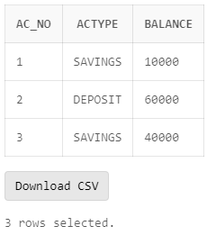

### Find the account holder name who has more than 2 accounts.

SELECT C.CNAME AS CUSTOMER_NAME,

(SELECT COUNT(H.AC_NO)

FROM HOLDS H

WHERE H.CID = C.CID

HAVING COUNT(H.AC_NO)>2) AS total_accounts

FROM CUSTOMER C;

1. Rename the accounts table as account details.

ALTER TABLE ACCOUNT

RENAME TO ACCOUNT_DETAILS;

### Find the loan amount and loan taken from which bank for each account holder.

SELECT C.CNAME AS ACCOUNTHOLDER, B.B_NAME AS BANKNAME, L.AMT AS LOAN_AMOUNT

FROM CUSTOMER C

JOIN AVAILS AV

ON AV.CID=C.CID

JOIN LOAN L

ON L.LOAN_ID=AV.LOAN_ID

JOIN OFFERS O

ON O.LOAN_ID=L.LOAN_ID

JOIN HAS H

ON H.BR_ID=L.LOAN_ID

JOIN BANK B

ON B.BANKID=H.BANKID;

### Find the account no. and account holder name who has not taken any loan.

SELECT C.CNAME AS ACCOUNTHOLDER

FROM CUSTOMER C

WHERE NOT EXISTS(

SELECT 1

FROM HOLDS H

JOIN AVAILS AV ON AV.CID = H.CID

WHERE AV.CID = C.CID

);

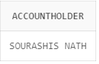

### Delete the account of all the persons who had accounts in PNB, Sealdah branch.

DELETE FROM ACCOUNT_DETAILS

WHERE AC_NO IN(

SELECT AC_NO

FROM MAINTAINS M

JOIN HAS H

ON M.BR_ID=H.BR_ID

WHERE H.BANKID=2 AND H.BR_ID=3

) ;

### Update the branch to SBI, Salt Lake branch for all the persons who had a SBI account in Sealdah branch.

UPDATE BRANCH BR

SET BR.LOCATION='SEALDAH', BR.BR_NAME='SBI-SEALDAH'

WHERE BR.BR_ID=1 AND BR.BR_ID IN(SELECT BR_ID FROM HAS H WHERE H.BANKID=1);

SELECT * FROM BRANCH;

### Find the maximum account balance of a person with account no 54321987654 among all of his accounts.

SELECT MAX(A.BALANCE) AS MAXIMUM_ACCOUNT_BALANCE

FROM ACCOUNT_DETAILS A

JOIN HOLDS H

ON A.AC_NO=H.AC_NO

WHERE H.CID IN (SELECT CID FROM HOLDS WHERE AC_NO=1 );